
ANALYSIS REPORT
COMP 258 - Assignment 1
Design and implement Shallow Neural Networks to predict/classify

Wardatul Keskin | 301294696
Due Date : September 28th, 2025
Professor: Muhammad Saiful Islam

CENTENNIAL COLLEGE

Exercise 1: Perceptron and ADALINE

Introduction
The purpose of this experiment was to design and implement simple neural networks, the Perceptron and ADALINE (Adaptive Linear Neuron), to classify letters represented as pixel patterns figure 2.20. Each input is a 7×9 grid (63 features), and the task was to classify D vs not-D.
This exercise provides hands-on experience with the Perceptron learning rule and the Delta Rule (used in ADALINE), illustrating how different learning rules influence convergence, accuracy, and robustness to noisy or incomplete data.

Theoretical Background

Perceptron Learning Rule
The perceptron uses a binary threshold activation (sign function). With the architecture below:
Figure 1. Perceptron Model
Activation function: step function
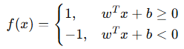
Learning rule: update only when misclassified
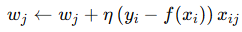
Learning type: stochastic/online – weights updated after each training example
Convergence theorem: If data is linearly separable, perceptron is guaranteed to converge in a finite number of steps

ADALINE
ADALINE uses a linear activation function instead of a step.
Figure 2. ADALINE Model
Activation function: linear (identity) during training
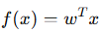
Error measure: Mean Squared Error (MSE)
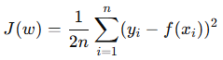
Learning rule (Delta Rule):
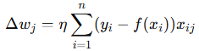
Learning type: batch gradient descent – weights updated using the cumulative error over all training samples

Experiment Setup

Data Preparation
Data: 21 letter patterns, converted from {0,2} to bipolar {–1,+1}.
Target: +1 for D (D_font1–3), –1 for not-D.

Models
- Perceptron: η = 0.1, max_iter = 200.
- ADALINE (same configuration): η = 0.1, max_iter = 200, scaled inputs.
- ADALINE (tuned): η = 0.01, max_iter = 500, scaled inputs.

Noise Tests
- Flip 5, 10, 15, 20 pixels.
- Set 5, 10, 15, 20 pixels to 0.

Results

Without Noise
=== Accuracy Comparison and Error Analysis===
Table 1. Model Accuracy and Error Patterns without Noise
Models | Accuracy | Error Patterns
Perceptron (η=0.1,max_iter=200) | 1.00 | None
ADALINE | 0.57 | [4, 5, 6, 7, 11, 13, 16, 17, 19]
ADALINE TUNED (η=0.01,max_iter=500) | 1.00 | None

Using Noise
=== Accuracy under noisy inputs ===
Table 2. Accuracy Result within Noisy Input
Noise Level | Perceptron | ADALINE | TUNED ADALINE
5 flipped | 0.76 | 0.57 | 1.00
5 missing | 0.86 | 0.52 | 1.00
10 flipped | 0.76 | 0.48 | 0.90
10 missing | 0.76 | 0.52 | 1.00
15 flipped | 0.90 | 0.24 | 0.95
15 missing | 0.90 | 0.52 | 1.00
20 flipped | 0.57 | 0.62 | 0.90
20 missing | 0.86 | 0.57 | 1.00
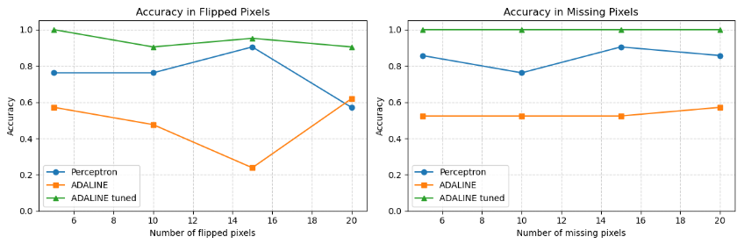
Figure 3. Accuracy Plot

Discussion and Conclusion
The results highlight both the strengths and weaknesses of the Perceptron and ADALINE models in line with the theory.
Result without Noise
- Perceptron: Achieved 100% accuracy with η = 0.1 and 200 iterations. This is consistent with the Perceptron Convergence Theorem, which guarantees that for linearly separable data, the perceptron will always find a separating hyperplane in finite steps.
- ADALINE (same config): Performed poorly (57% accuracy), misclassifying 9 patterns. The error shows that the decision boundary failed to generalize correctly. This happened because ADALINE minimizes Mean Squared Error (MSE), and with a large learning rate (η = 0.1) and few iterations, the updates overshot the error surface.
- ADALINE (tuned): With η = 0.01 and 500 iterations, ADALINE also converged perfectly (100% accuracy). This confirms that ADALINE can match the Perceptron’s performance but only when hyperparameters are carefully tuned and input features are scaled.

Result with Noise
- Perceptron: Achieve fluctuating results in both missing and flipped pixels. This happens because the perceptron uses a step activation with stochastic (online) updates only on misclassified examples, making its decision boundary sharp and highly sensitive to small input changes. As shown in the plots, accuracy bounces between 0.76 and 0.90 for missing pixels and between 0.57 and 0.90 for flipped pixels, since removing or flipping different subsets of pixels can either disrupt critical features of “D” or remove less-relevant ones, leading to instability in performance.
- ADALINE: Produces consistently low accuracy under both flipped and missing pixels. This happens because ADALINE minimizes squared error in batch learning, updating weights even for correctly classified samples. With a large learning rate (η=0.1) and few iterations, the model fails to converge properly, leading to unstable and weak separation boundaries. In the plots, accuracy hovers around 0.48–0.62 for missing pixels and drops as low as 0.24 for flipped pixels, showing that the poorly tuned ADALINE is unable to generalize in noisy conditions.
- ADALINE (tuned): Tuned ADALINE shows the most stable and reliable performance when pixels are flipped or missing. With a smaller learning rate (η=0.01), more training iterations (500), and scaled inputs, the model is able to learn more carefully and reach a strong solution. In the plots, its accuracy stays at 1.00 for all levels of missing pixels and only drops slightly under flipped pixels (from 1.00 at 5 flips to 0.90 at 20 flips). This means tuned ADALINE not only performs perfectly on data without noise but also handles noisy conditions better than the Perceptron.

Exercise 2: Multi Layer ANN

Introduction
In this exercise, a multilayer artificial neural network (ANN) was implemented manually using NumPy to classify hepatitis patient outcomes (Die vs. Live). The architecture followed the specification:
- Input layer: 19 neurons
- Hidden layer 1: 30 neurons
- Hidden layer 2: 15 neurons
- Output layer: 2 neurons
- Activation: Sigmoid in all layers
- Loss function: Mean Squared Error (MSE)
The goal was to observe how the network learns from initial random weights and activations, to final trained predictions, while tracking convergence via MSE loss.

Theoretical Background

Artificial Neural Networks (ANNs)
An Artificial Neural Network is a computational model inspired by the human brain. It consists of layers of interconnected nodes (neurons) that process input data and learn complex mappings through training. ANNs are powerful for classification, regression, and pattern recognition tasks.
Figure 4. ANN Multi Layers model
General algorithm for the modern version of a neural network in the following steps:
- Calculate the feedforward signals from the input to the output.
- Calculate activation Function: Sigmoid.
- Calculate Loss Function by measuring the difference between predicted output and actual output.
- Backpropagate the error signals by weighting them by the weights in the previous layers and the gradients of the associated activation functions.
- Calculate the gradients 𝛿E/𝛿θ for the parameters based on the backpropagated error signal and the feedforward signals from the inputs.
- Update the parameters using the calculated gradients θ ← θ - η 𝛿E/𝛿θ .

Experiment Setup

Data Preparation
Dataset: Hepatitis training set (152 samples, 19 features) and testing set (3 samples).
Missing values: None detected, but mean imputation included.
Normalization: StandardScaler applied for zero mean and unit variance.
Encoding: Target labels (Die_Live) were one-hot encoded:
  - Die = [1, 0]
  - Live = [0, 1]
Final dataset:
- Training features: (152 × 19)
- Training labels: (152 × 2)
- Testing features: (3 × 19)
- Testing labels: (3 × 2)

Training Setup
Loss function: Mean Squared Error (MSE)
Learning rate (η): 0.5
Epochs: 2000
Gradient descent (manual implementation)

Results
Initial Activations (before training, first 5 samples)
- Hidden layer outputs were close to 0.5 (due to small random weights).
- Output neurons gave probabilities near [0.50, 0.50], showing an untrained, uncertain state.
Training Loss Curve
- Initial MSE loss: 1.38
- Loss decreased smoothly:
- Epoch 500: 0.44
- Epoch 1000: 0.23
- Epoch 2000: 0.08
- The consistent drop in MSE indicates successful convergence.
Final Activations (after training, first 5 samples)
- Hidden layers became more polarized, showing meaningful feature extraction.
- Output neurons produced probabilities strongly aligned with one-hot targets, e.g.:
- Predicted [0.012, 0.988] vs Actual [0, 1] (Live)
- Predicted [0.995, 0.005] vs Actual [1, 0] (Die)
Accuracy
- Train accuracy: 99.34%
- Test accuracy: 100.00%
Graphic Plot
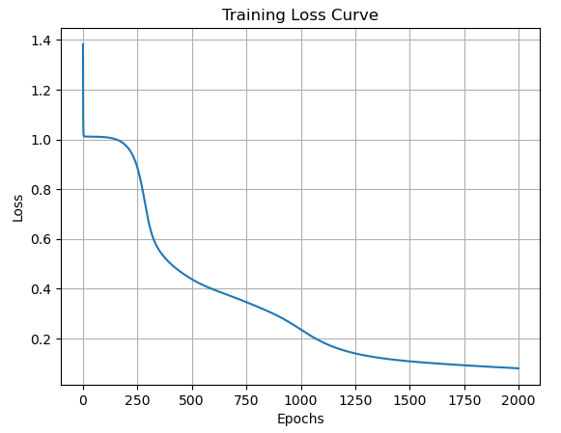

Discussion and Conclusion
- Initial activations showed untrained randomness, while final activations aligned with expected targets.
- The ANN successfully minimized MSE, dropping from 1.38 to 0.08.
- Achieved 99.34% training accuracy and 100% test accuracy.
- The experiment validated the effectiveness of ANNs and reinforced understanding of forward propagation, backpropagation, and the role of the loss function in driving weight updates.

